
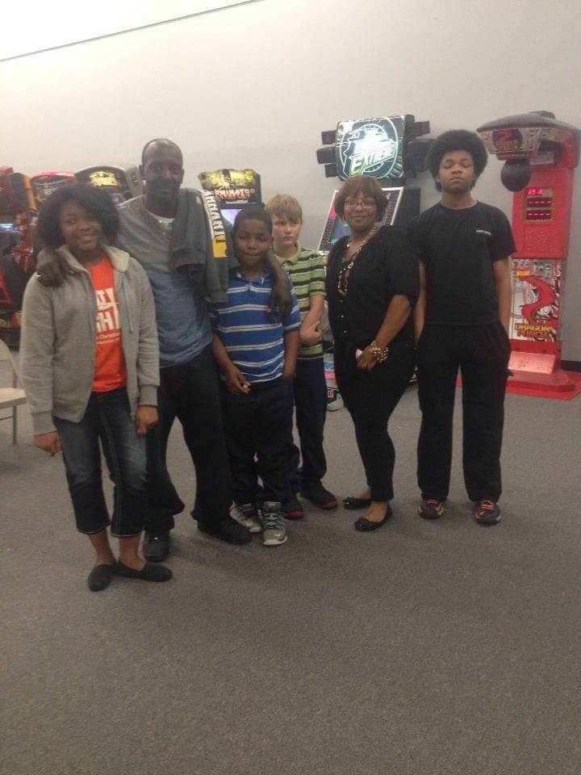

Love is…

Khalil Ross Jefferson

Mother’s of multiples can agree there is no such thing as a “favorite”. Your mind automatically sets to equal love amongst the group. One love; one heart; one family. Period. No favorites.  What you do have is the child that wants to spend time with you even it’s not cool. The one whose room you could stay in a little longer before the inevitable teenage emotional shutdown. The one that somewhat understood “What’s going on?” meant love not war. The child that naturally becomes the leader even though everyone is basically the same age. The child that needs more hugs or more kisses or has more “bad” days. Although in that situation you then find yourself kissing the rest just as lovingly cause well duh… no favorites. There’s the one that calls the most… so then you call the others cause “I just talked to your brother and your name came up. What are you up to?” “Your sister just called and guess what she said…” “Did you know your brother just…”. The one that even the algorithms understood they would “get it” so you find yourself sending them more reels than the others. Which meant sending more to everyone else to “balance it out”. There’s the one that wants to walk with you. Talk with you. And pick your brain. There’s the one that says I love you after every call. And is ok when you say… wait… did you hear me when I said I love you? The phone hung up…  And so it goes on and on. |  | Spelling Bee Champs!  The semicolon is for when life continues even after you thought it stopped.

